Latent Space Exploration and Image Generation using Deep Convolutional Generative Adversarial Networks (DCGANs)

Abstract
This project details the implementation of a Deep Convolutional Generative Adversarial Network (DCGAN) using PyTorch to synthesize realistic 64x64 human faces from the CelebA dataset. To streamline training, a custom cloud-based data pipeline was engineered, enabling the model to successfully learn 100-dimensional latent space representations over 20 epochs. Finally, an interactive graphical interface was developed to perform real-time linear interpolation between random noise vectors, validating the network's ability to generate smooth, continuous transitions between distinct facial features.

Introduction
Generative Adversarial Networks (GANs) represent a significant breakthrough in generative modeling. A standard GAN consists of two neural networks locked in a continuous, zero-sum game: a Generator and a Discriminator. The Generator attempts to create synthetic data that is indistinguishable from real data, while the Discriminator acts as a classifier, attempting to distinguish between the real dataset and the Generator's fakes. Over time, both networks improve, ideally resulting in a Generator capable of producing highly realistic outputs. A Deep Convolutional Generative Adversarial Network (DCGAN) improves upon this foundation by explicitly utilizing convolutional and convolutional-transpose layers, making it exceptionally well-suited for high-fidelity image synthesis tasks such as human face generation.

Motivation
The ability to generate synthetic yet highly realistic human faces have profound implications across multiple domains. In the field of machine learning, high-quality generated images can be used for data augmentation, helping to train robust computer vision models when real-world data is scarce. Furthermore, synthetic face generation is crucial for privacy-preserving applications; researchers can share and utilize datasets of generated faces without compromising the biometric data of actual individuals. Finally, exploring the latent space of these models provides deep insights into how neural networks learn and represent complex physical attributes.

Literature Review & Research Gaps
The foundational framework for this project was established by Ian Goodfellow et al. in their seminal 2014 paper, Generative Adversarial Nets, which introduced the adversarial training paradigm. However, early standard GANs utilizing multi-layer perceptrons struggled with spatial resolution and training stability. This gap was addressed by Radford et al. (2015) in Unsupervised Representation Learning with Deep Convolutional Generative Adversarial Networks, which introduced specific architectural constraints (such as batch normalization and the removal of fully connected hidden layers) to stabilize training for image data. Despite these advancements, training DCGANs remains notoriously challenging. Research gaps persist regarding the prevention of "mode collapse" (where the Generator produces limited varieties of images) and the difficulty of balancing the learning rates between the Generator and Discriminator. This project aims to navigate these exact challenges through careful hyperparameter tuning and dynamic latent space visualization.

Methodology
To ensure reliable and rapid data fetching, the standard Google Drive-based dataset download was bypassed in favor of a custom cloud pipeline utilizing the Kaggle API. This fetched the CelebFaces Attributes (CelebA) dataset directly to the compute environment, where a custom PyTorch DataLoader was engineered to process the images. The preprocessing pipeline consisted of a CenterCrop to 160x160 to isolate facial features, resizing to 64x64 pixels to match the network requirements, and normalizing the pixel values to a range that mathematically align with the Generator's final activation layer.

The network architecture follows the established DCGAN guidelines, utilizing deep convolutional networks without fully connected pooling layers. The Generator takes a 100-dimensional random noise vector (sampled from a standard normal distribution) as input and utilizes a series of ConvTranspose2d layers to systematically upsample the spatial dimensions. Batch Normalization and ReLU activation functions are applied after each layer, concluding with a Tanh activation to produce the final 64x64 RGB image.
Conversely, the Discriminator acts as a binary classifier. It takes a 64x64 image as input and passes it through a series of standard Conv2d layers to downsample the image, utilizing LeakyReLU activations to prevent sparse gradients, and concluding with a Sigmoid activation function to output a probability score.
The model was trained over 20 epochs using the Google Colab NVIDIA T4 GPU infrastructure. Both networks were optimized using the Adam optimizer with a learning rate of 0.002 and a momentum parameter of B1 = 0.5, which has been empirically shown to stabilize GAN training. The networks were trained simultaneously using Binary Cross Entropy (BCE) Loss, pushing the Discriminator to correctly identify real/fake images while penalizing the Generator when its images were successfully caught. Finally, to evaluate the model's structural understanding rather than just its visual output, an interactive evaluation module was developed using ipywidgets. This interface performs real-time linear interpolation between two random 100-dimensional latent vectors, visually demonstrating the continuous nature of the learned morphological transitions.

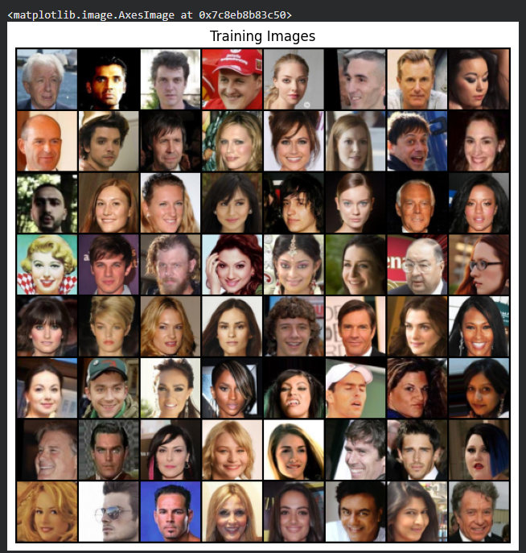

Results and Visualizations
The successful training of the DCGAN was validated through both static visual inspection of the generated outputs and dynamic exploration of the latent space.
During the initial phases of training, the Generator established a fundamental understanding of facial geometry.
By Epoch 9, the network successfully mapped the structural anchor points of a human face (eyes, nose, and mouth placement), though the outputs lacked high-frequency details, resulting in blurred, weird textures. Upon completing the full 20 epochs, the Generator significantly improved its localized feature mapping, producing sharper structural boundaries and more coherent skin textures, demonstrating the model's convergence.
To prove that the Generator learned a continuous, semantic representation of human faces rather than memorizing the training data, a linear interpolation was performed between two distinct random vectors in the latent space. The custom interactive widget demonstrated smooth morphological transitions. As the blend ratio shifted from 0 to 1, the generated image did not fade like overlapping transparencies; instead, the physical geometry warped and morphed naturally.

Conclusion
This project successfully implemented and stabilized a Deep Convolutional Generative Adversarial Network (DCGAN) using PyTorch. By engineering a custom, cloud-based Kaggle data pipeline, the limitations of standard Drive-based dataset acquisition were entirely bypassed, allowing for efficient processing of the CelebA dataset. The adversarial training regime successfully balanced the Generator and Discriminator over 20 epochs. Ultimately, the development of an interactive interpolation interface proved that the network successfully learned a continuous, high-dimensional mathematical mapping of human facial features, fulfilling the core objective of the research.

Future Scope
While the current architecture successfully synthesizes 64x64 images, future iterations of this project could explore several advancements:
- Higher Resolution Synthesis: Implementing Progressive Growing GANs (ProGAN) or StyleGAN architectures to scale the output resolution to 256x256 or 1024x1024 without destabilizing the training process.
- Conditional Generation: Upgrading the architecture to a Conditional GAN (cGAN), which would allow the user to input specific text or class labels (e.g., "generate a face with sunglasses" or "generate a face with blonde hair") to control the exact output.
- Modern Paradigms: Comparing the computational efficiency and output fidelity of this DCGAN against modern Diffusion Models (such as those powering DALL-E or Midjourney) for the same facial synthesis task.

